Year 9 Quiz 1 Biological Science
Name:______________ Class:______ Date:_______ Score:_____/60
Identify the activity that would be difficult after sustaining damage to the brain stem.
- speech
- walking
- breathing
- intellectual thought

Select the CORRECT statement from below:
- The brain is made up of two hemispheres – right & left cerebellum hemispheres
- The occipital lobe is important in the brain for alertness and sleep modulation
- The axon is an extremely long part of the cell of a neuron and contains dendrites
- Lateralisation is when each half of the brain controls the opposite side of the body

Name two parts of the autonomic nervous system.
- central nervous system and parasympathetic nervous system
- peripheral nervous system and parasympathetic nervous system
- sympathetic nervous system and parasympathetic nervous system
- central nervous system and peripheral nervous system

Listed are the three most important things the Brain needs to function well
A Sleep Drugs Sugar
B Sleep Oxygen Blood flow
C Drugs Sleep Nutrition (food & water)
D Sleep Oxygen Nutrition (food & water)

Select the CORRECT statement from below:
- The frontal lobe is important for higher thinking and intelligence
- The neuron does not contain a nucleus
- Grey Matter surrounds the entire spinal cord
- The sensory neuron is part of a reflex arc that sends messages back to the effector

The cerebellum does NOT control
A body temperature B posture
C co-ordination D balance

Section A— Multiple choice
Instructions: Select ONE correct answer for each multiple choice.

Section B— Short Answer
- ` | a Describe sensory receptors.  _____________________________________________________________________________________________________________________________________________________________________________________________________________(2)  b What is the function of sensory receptors.  _____________________________________________________________________________________________________________________________________________________________________________________________________________(2)  c In the TABLE  Label 4 Major types of sensory receptors of the body  and Describe the function of each type of receptor  (4)
  Type of Receptor | Function of receptor type
  Mechanoreceptors
  Photoreceptors
  Chemoreceptors
  Thermoreceptors
2a Reflex actions are described as involuntary. Explain what this means.
____________________________________________________________________________________________________________________________________________________________________________________________________________ (2)
2b Label the example of someone touching a hot item
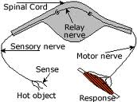
Sensory Neuron
Interneuron
Motor Neuron
Receptor
Effector
Spinal Cord
(6)

2c, Explain how reflex actions are helpful to people.
____________________________________________________________________________________________________________________________________________________________________________________________________________________________________________________________________________________________________________________________________________ (2)
2d. Match each type of neurons with its function
Sensory neurons InterNeurons Motor neurons
______________________ Pass information from sensory to motor neurons
______________________ Move messages to muscles and glands of body
______________________ Collect information from stimuli in sense organs (3)

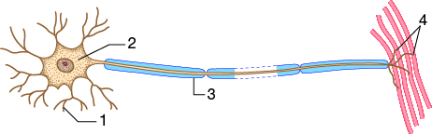
3a. Label the parts of the neuron
1_____________________________________
2_____________________________________
3_____________________________________
4_____________________________________ (4)

3b. What is the difference between a neuron and a nerve.
Neuron____________________________________________________________________________________________________________________________________Nerve___________________________________________________________________________________________________________________________________(1)

3c. What are the two functions of part 3 of the neuron.
- _______________________________________________________________________________________________________________________________________________________________________________________________________
- _______________________________________________________________________________________________________________________________________________________________________________________________________ (2)

Describe the function of each of the following parts of the brain. (8)
Part of brain | Function
Frontal Lobe of Cerebrum
Cerebellum

 | This lobe is involved in processing visual information
White matter

Temporal Lobe of Cerebrum
 | Role is to control breathing, heart rate and vital functions.
 | Structure located at the base of the brain responsible for manipulating levels of wakefulness, tiredness, sleep response
Corpus Callosum/ Midbrain

5a. A RECEPTOR is a specialised nerve. The receptors main function is
A. Send a message from the brain to the muscles B. Carries out a response
C. Sends message to the central nervous system from an organ D. Detects a stimulus (1)
5b. Select the response that is NOT a reflex
A Sweating on a very hot day B Jumping quickly when you step on sharp object
C Moving hand away from hot object D Blinking when object is thrown at your eyes (1)
5c. Complete the table to describe relationships between stimuli and their receptors.
Stimulus | Receptor | Location
Light
Chemicals
 | Semicircular canals | In the EAR
 | Cochlea cells | In the EAR
(6)

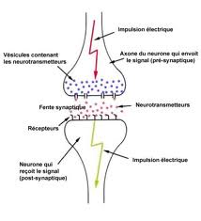
6a. Label the diagram (5)

- Neurotransmitter
- Synaptic gap
- Dendrite
- Axon Terminal
- Direction of electrical impulse

b. Explain what happens at a synapse
____________________________________
____________________________________
____________________________________
____________________________________
____________________________________________________________________________________________________________________________________________ (3)
Colour/shade the parts of the Central nervous System on the Diagram (2)
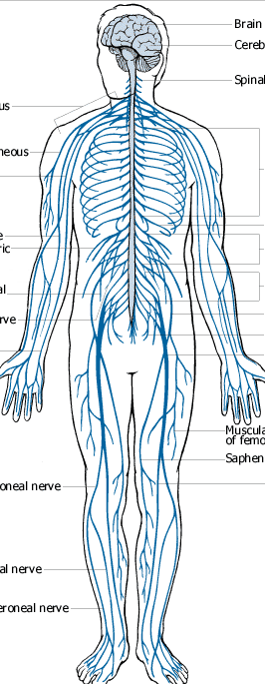

End of Test
Please Check all answers

